Example: Water pump efficiency

Calculate the pump’s efficiency for a small irrigation pump, such as a sprinkler pump of 1 HP with the following specs (e.g., Flotec Thermoplastic Sprinkler Pump 1 HP):
Horsepower 1
Gallons Per Minute (GPM) 55
Best for use at maximum depth of <20' or 6m
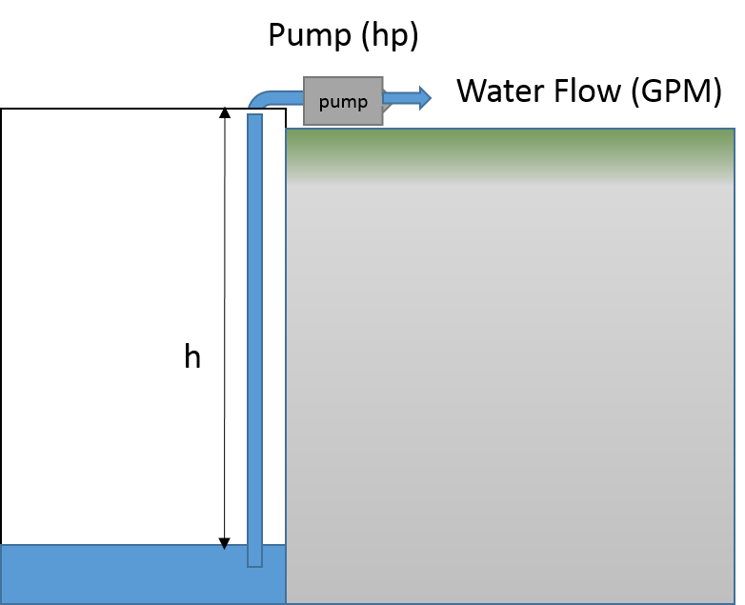
Units & Unit Conversions involved:
1 Ga = 3.79 L
Mass of one liter of water; ml = 1 kg
Mass of 1 gallon of water; mg = 3.79 kg
Watts ≡ kg. m2 / s3

$$P=\frac{W}{t}= \frac{∆E}{∆t}= \frac{∆\left(mgh\right)}{∆t} =g h \frac{∆m}{∆t} \\ \frac{∆m}{∆t}= \frac{p}{gh}= \frac{\left(1.0 hp\right)\left(\frac{746 W}{1 hp}\right)}{\left(9.8 m.s^{-2}\right)\left(6m\right)}=\frac{\left(1.0 hp\right)\left(\frac{746 kg.m^{2} . s^{-3}}{1 hp}\right)}{\left(9.8 m.s^{-2}\right)\left(6m\right)}$$
$$=12.69 kg.s^{-1} = \left(12.69 kg.s^{-1}\right)\left(\frac{1 Gallon}{3.79 kg}\right)$$
= 3.34 GPS = 200.85 GPM (this is Gallon per minute assuming 100 % efficiency

Calculated Water Pump efficiency $=\frac{55 GPM}{200.85 GPM }*100=27.38\%$

SumpMarine UTP 115-Volt 330 GPH Portable Transfer Water Pump, Bronze
Fpower Portable Transfer Water Pump Battery Powered Self-Priming Pump -12V, 300 GPH, 3/4" Garden Hose

Example: Water Pump Power
A water pump system must be able to raise 8 gallons of water every minutes up to a height of 10 m (pumping water from 10 m underground water source to the ground level). The density of the water is 1.04 g/cm³, due to the minerals in the water.
- What is the work done to lift one liter of the water?
- What is the operating power of the water pump, assuming its efficiency is rated as 23.5 %?

Density $D=1.04\frac{g}{{cm}^{3}} \left(\frac{1 {cm}^{3}}{1 ml}\right)\left(\frac{1000 ml}{1 l}\right)\left(\frac{1 kg}{1000 g}\right)=1.04\frac{kg}{l}= \frac{m}{1l}$
m = 1.04 kg
F = mg = (1.04 kg) (-9.8 m/s²) = -10.2 N
Therefore; W = (10.2 N) (10 m) = 102 J Work done to raise one liter of water by 10 m
Volume = 8 Gallons = (8 Gallons) $\left(\frac{3.79 l}{1 Gallon}\right)=30.32 l$
The work done to move 8 gallons or 45.48 l of water is then = (102 J) (30.32) = 3092.6 J
Leading to $P= \frac{w}{t}= \frac{3092.6 J}{60 sec}=51.54 Watts=\left(51.54 Watts\right)\left(\frac{1 hp}{745.7 Watts}\right)=0.069 hp$

Assuming 23.0% efficiency for the water pumping system the electric power needed to run the pump is; $\frac{ 0.069 hp}{0.23}= 0.3 hp$

Example: Water Pump Operation

Could a 1.0 horsepower (hp) water pump can pump 10 Gallons per minute from a maximum vertical depth of 10m, if the pump efficiency is 50%?
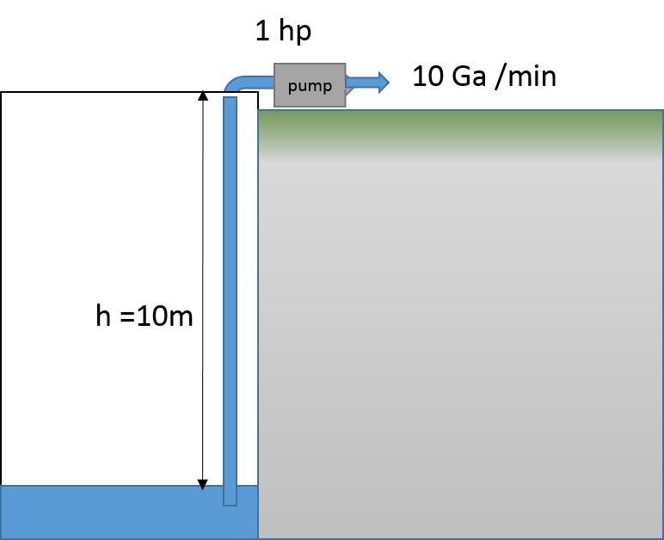
Units & Unit Conversions involved:
1 Ga = 3.79 L
Mass of one liter of water; m_{l} = 1 kg
Mass of 1 gallon of water; m_{g} = 3.79 kg
Watts ≡ kg. m² / s³

$$P= \frac{W}{t }= \frac{∆E}{∆t}= \frac{∆(mgh)}{∆t}=gh \frac{∆m}{∆t}$$
$$\frac{∆m}{∆t}= \frac{p}{gh}$$
$\frac{∆m}{∆t}= \frac{\left(1.0 hp\right)(\frac{746 W)}{1 hp}}{(9.8\frac{m}{s^{2} })(10 m)}= \frac{\left(1.0 hp\right)(\frac{746 kg. m2 / s3}{1 hp}}{(9.8\frac{m}{s^{2} })(10 m)}$
$=$7.61 kg /s
= (7.61 kg/s)(1 Gallon / 3.79 kg)
= 2.00 g/s = 120 g/m assuming a pump with 100% efficiency
= 60 g/m at assuming a pump with 50% efficiency

I psi = 6.894757 kPa

https://www.globalspec.com/SpecSearch/SearchForm/flow_control_flow_transfer/pumps/water_pumps

